## **What is replication in kubernetes workload resources?**

Replication in kubernetes means that a number of pods are created and maintained according to the specified replicas.

Replication provides the below benefits in kubernetes:

* Reliability: It ensures that there are a minimum number of pods running on the cluster without any downtime to the application.

For example, if the replicas is mentioned as 3 in a deployment, if a pod is down then it makes sure to create another pod such that there are the same number of pods as mentioned in replicas.

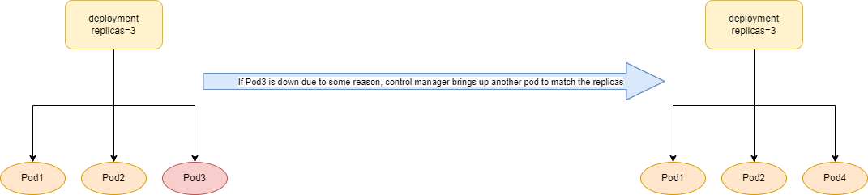

* Load Balancing: We can add a service object to manage the load/traffic and spread it among the other pods/nodes.
* Scaling: We can upscale or downscale the number of replicas based on our requirement.

This is why it is advised not to use kubernetes stand-alone pod for our kubernetes applications and rather use these resources.